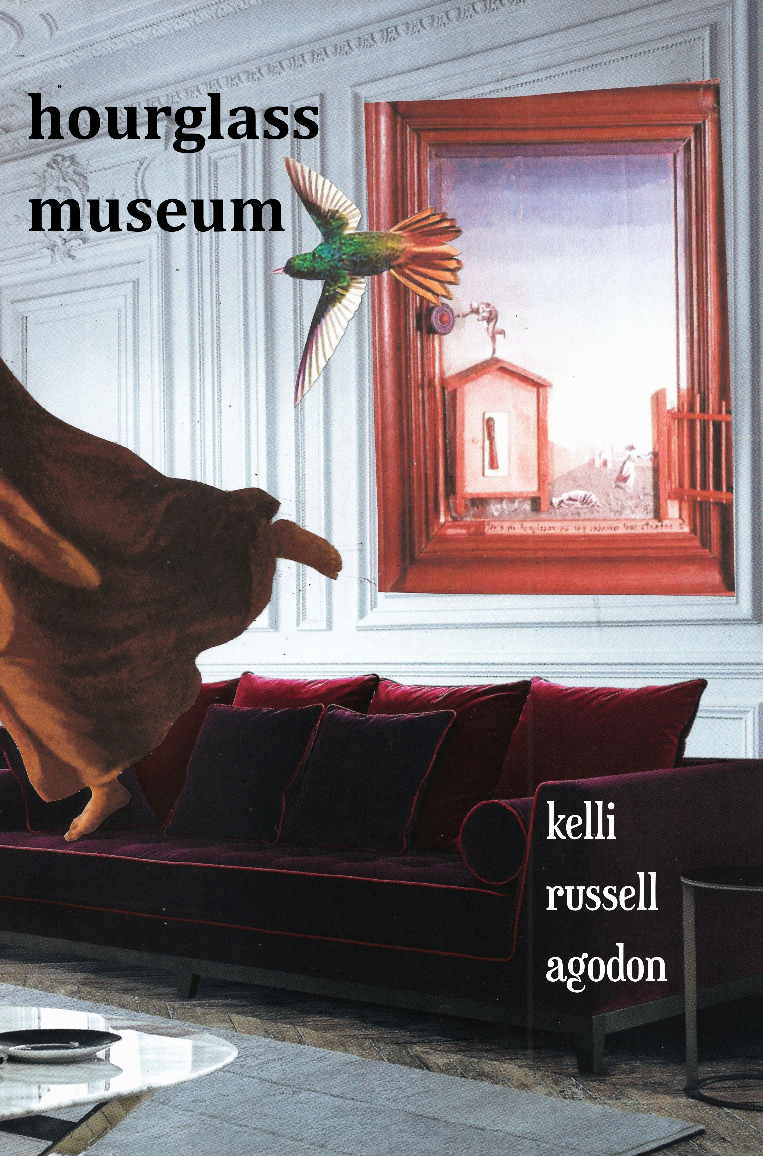
Reader’s Guide for Hourglass Museum
by Kelli Russell Agodon

The purpose of this Reader’s Guide for Hourglass Museum by Kelli Russell Agodon is to help you or your book group develop a stronger understanding of the poems and ideas behind this collection. Our hope it that these questions create interesting discussion or helps you ponder new ideas, thoughts, and interpretations behind the poems and less direct you towards an opinion about Agodon’s poetry.

It has been said that Kelli Russell Agodon’s Hourglass Museum, was built with the belief that the undeniable yearning to create is what moves us forward. Through car rides with Andy Warhol, temporary tattoos of Frida Kahlo, and long dinners with Joseph Cornell, we walk hand-in-hand through a paper museum where what inspires intersects with our regular lives.

Hourglass Museum offers poems inspired by artwork and artists that explores personal relationships and the struggle (emotionally, financially, and spiritually) of living a creative life. Agodon understands the importance of how art influences our lives and how we balance delicately realizing that we only have so much time to live and create.

Questions for Discussion:

PORTRAITS:
- In the first poem “The Broken Column” the poet writes, “I believe we all love something we don’t talk about.” Do you feel this is a true statement, why or why not? (Extra credit: What is something in your own life you love (or have love for), but do not talk about because it makes you feel embarrassed, vulnerable, or afraid?

- In “A Moment Ago, Everything Was Beautiful” the speaker seems to be in conversation with her spouse in the kitchen. There is an underlying theme of growing older and/or not being able to do something we once were able to do. In the penultimate and final stanzas, Agodon writes: “You said, Sometimes I still want to be needed,//so I let our kitchen become a flood/of time and you the only thing keeping me/from going under.” What do these lines mean, and what do you think the speaker means when she says, “from going under?”

- If you read the “Notes” section from the back of the book, you may determine that poem “After You Tell Me You Want To Build A Diorama of Your Grandmother’s Suicide” is nonfiction and was written about something that actually happened to the poet. But poetry doesn’t have to be factual or based on real events either in the poet’s life or in history. As a reader, do you prefer poems that know are true, or does it matter if the poet takes creative license to get to a larger “truth” or Truth (with a capital T)? Since many poems come from a poet’s imagination, do you get a sense of satisfaction when you know a poem is true or based on a true story, or does it matter? What are you looking for when you read a poem?

- The final poem in the “Portraits” section is “Self Portrait With Reader.” The poem begins with the line, “To create is not enough.” If creating is not enough, what is the poem suggesting is just as important if not more important than living a creative life? Do you agree with the line, “We must live with our hearts / in our hands—like Mary.” What do those lines and image mean to you?

SKETCHBOOK OF NUDES:

- The first thing you may notice about the poems in this section is that they are without capitalization or titles. They can be read individually or as one long poem. Why to do you feel the poet wrote the poems in this section this way when none of the other poems lack capitalization, punctuation, and/or titles? Do you feel this section adds to the book as a whole or takes away from it?

- In the poem, “I wonder if might be lonelier,” the poet writes, “If the trophy on the mantel/has meaning//what do the oversights represent” or in other words, if we are believe praise is true, how do we continue to be an artist when nobody notices us? Do you believe that praise is needed in our lives and if we choose to believe in our praise do we also need to believe our criticism? How can we live artful lives and continue to create without needing outside validation? Is it possible?

- In the final poem “make beautiful things,” the image of Frida and the temporary tattoo return. Why does the poet return to this image? Do you think Frida Kahlo is acting as museum muse throughout this book? Why or why not?

INK AND WATERCOLOR

- This section begins with the poem “Sketchbook With an Undercurrent of Grief.” Near the end of the poem, Agodon writes, “Did I start out by saying:/ I escape disaster by writing a poem with a joke in it? / Those last five words weren’t necessary.” Is the poet saying that she deals with life’s tragedies by using humor in her poems or that she deals with life’s tragedies just by writing about them? Or is it a little of both? Do you think writing or reading poetry can be therapeutic? How does poetry help others, or does it? Have you ever written a poem to process or “deal with” a difficult subject?

- In “Directions on Collecting and Preserving Humans,” Agodon appears to be comparing the hobby or science pinning of insects to getting acupuncture. The poem is centered on sorrow and the dialogue between patient and doctor. At the end, the acupuncturist says, “Once there was a ‘you’/ in euphoria, but we don’t live there, we don’t live in that box anymore.” Do you think the doctor is saying that as we get older we lose our joy or is she saying something more general about our culture? And when she uses the term “box” is that a metaphorical box or a reference to the boxes insects are pinned inside of? If you believe it refers to an insect box, is the doctor saying that we are just insects trapped inside of something or by “box” does the doctor mean we create our own boundaries?

- The poem “How To Be a Genius in Many Different Fields” was created from watching hours of interview footage with Salvador Dali along with the poet’s own imagination. Each line is almost a meditation or rumination on how to live your life. Which of these lines do you most connect with and why? Which of these lines to feel is untrue? How come?

SPECIAL EXHIBITION: HER INVENTED MUSEUM

- Many of America’s most successful women artists and writers, do not have children. In the final section of Hourglass Museum, we appear to get a deeper look into a personal struggle the speaker seems to be having with finding balance in her life between family and art. Can women follow their artistic instincts and still function as spouses and mothers? What are the challenges? Are women who are also mothers seen as selfish if they focus on their art or careers? Whether you are a parent or not, what sacrifices or choices have you had to make in your own life to do something you were passionate about?

- In the poem, “Luxury, Calm, and Desire,” this question is asked: Who’s to say what’s a weed, what’s a wildflower? Why is this question being asked? Do you believe it’s true? Does our perception on something create either beauty or ugliness? Can you switch perception to see something ugly as beautiful? Do you sometimes struggle with finding the positives of a situation or how do you become grateful in your life?

- A few poems in Hourglass Museum come with “An Abstract” in the title. There are two poems (“Menacing Gods: An Abstract” & “Darling: An Abstract”). How does these poems differ from other poems in the collection? How are these poems similar to an abstract painting? As a reader, are you comfortable with poems with less direction in them and perhaps, more flow, more varied subjects? Are you able to appreciate the poem for what it is even without a certain or definite understanding of it? Why or why not?

- In the last poem, “Darling: An Abstract,” the poem ends with the line: In the simplest way, we are all becoming the light. What are the many interpretations of this line and what does it mean to you? Why did the poet end her book with this line and image and the word, “light.” How does light play into visual art and how does light play into this collection?

Questions for Discussion: The Book as a Whole—

- Why do you feel the collection is entitled Hourglass Museum? How is this book also a museum, or is it? Why do you feel Agodon chose the word hourglass to pair with museum?

- What surprised you most about this collection?

- Many of the poems in this collection are ekphrastic poems. These are poems that were inspired by a certain artwork. The goal of these poems is to exist on their own as well as create a deeper understanding and interpretation when viewing the artwork at the same time or before reading the poem. Why do you feel the poet included so many ekphrastic poems in this manuscript? How does creating poems inspired by other work add to the conversation of art, artistic lives, and creativity, or does it?
- Were there any references to artists or artwork that you have never heard of? If yes, take a moment to google their work. Now read the poem again, does it change your interpretation of the poem in any way?

- The poet has a large section of notes in the back of the book for more information about many of the poems. As a reader, do you enjoy having these bits of extra knowledge available or do you find the note section cumbersome and unneeded? Why do you feel Agodon included such a lengthy note section? Did anything in the note section surprise you?

- If you were to write a book that is in the form of a paper museum, what would be your topic or what artist would you want to write about?
_____________________________________________________
Other inspiring books, films, & products on living a creative life recommended
by Kelli Russell Agodon:
Books:
The Creative Habit: Learn it & Use It For Life, by Twyla Tharp
The Accidental Creative: How to Be Brilliant at a Moment's Notice by Todd Henry
Die Empty: Unleash Your Best Work Every Day by Todd Henry
The Daily Poet: Day-By-Day Prompts for your Writing Practice
by Kelli Russell Agodon & Martha Silano

Films:
Who Does She Think She Is? (Documentary)
Beauty is Embarrassing: The Wayne White Story (Documentary)
Il Postino (foreign film)
Midnight in Paris (comedy, romance, fantasy)
Exit Through the Gift Shop Window (documentary)
Marwencol (documentary)

The Poet Tarot & Guidebook (produced by Two Sylvias Press: www.twosylviaspress.com)
Bio for Kelli Russell Agodon –

Kelli Russell Agodon is a prize-winning poet, writer, and editor from the Northwest.
She is the author of three full collections of poems: Hourglass Museum, Letters from the Emily Dickinson Room (White Pine Press, 2010), Winner of the ForeWord Magazine Book of the Year Prize in Poetry and a Finalist for the Washington State Book Award, and Small Knots (2004). She is also the author the chapbook, Geography (2003), The Daily Poet: Day-By-Day Prompts For Your Writing Practice, and the coeditor of Fire On Her Tongue: An Anthology of Contemporary Women’s Poetry.

Born and educated in Seattle, Washington, Kelli graduated from the University of Washington and received her Master of Fine Arts from Pacific Lutheran University’s Rainier Writing Program. She is the co-founder of Two Sylvias Press and was the editor of Seattle’s literary journal, Crab Creek Review for the last six years.

She lives in a small rural seaside community, a ferry ride away from Seattle, where she is an avid mountain biker, paddleboarder, and hiker. She never underestimates the power of museums and good dessert to heal what ails. Her favorite dessert is Key lime pie and while she loves the Seattle Art Museum where she saw the Andy Warhol exhibit that inspired a few of the poems in Hourglass Museum, she holds a special place for two smaller museums: The Frye Art Museum & the Tacoma Art Museum, both museums she returns to regularly to feel inspired and fulfilled.

She writes about living and writing creatively on her blog, Book of Kells at: www.ofkells.blogspot.com

Visit her at www.agodon.com or on Facebook at: www.facebook.com/agodon
Or write to her directly at: kelli@agodon.com

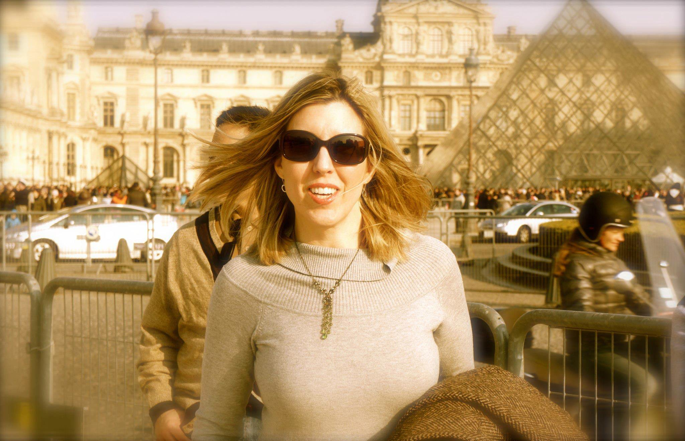
Kelli Russell Agodon
The Louvre, Paris, 2013
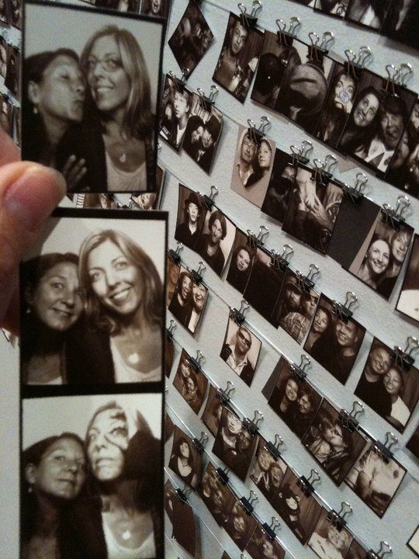

Kelli with Susan Rich
at the Andy Warhol exhibition
Seattle Art Museum, Summer 2010
Thank you for your interest in Hourglass Museum by Kelli Russell Agodon.

Other books by Kelli Russell Agodon include:

The Daily Poet: Day-By-Day Prompts For Your Writing Practice: coauthored with Martha Silano
Letters from the Emily Dickinson Room (White Pine Press, 2010)
Fire On Her Tongue: An Anthology of Contemporary Women Poets (Two Sylvias Press, 2010)
Small Knots (Cherry Grove Collections, 2004)
Geography (Floating Bridge Press, 2003)

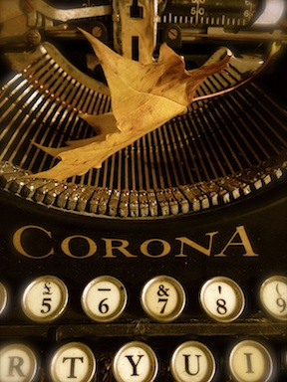

Write to Kelli at:
Kelli Russell Agodon
Or by email at:
kelli@agodon.com

www.agodon.com
PO Box 1524
Kingston, WA 98346

